Mixed Diamine-Thiolate Ni Complex: The Case of an Abundant Green Catalyst for the Photoreduction of Water

Fotios I. Kamatsos , Christiana A. Mitsopoulou*
Chemistry Dep., Inorganic Chemistry Lab., National and Kapodistrian University of Athens, Panepistimiopolis Zografou, 15771 Athens, Greece
fotiskam@chem.uoa.gr, cmitsop@chem.uoa.gr

Abstract
Hydrogen production by water splitting is a holy grail of science, being one route to a non-fossil fuel and a potential source of clean energy. The photocatalytic cleavage of water is one way to utilize sunlight energy. For this purpose both photosensitizers and catalysts are required [1]. Neutral metal bis-dithiolene and mixed diamine-dithiolate complexes have attracted the interest of inorganic chemists and physicists for multiple reasons [2]. In 1990’s some bis-dithiolene [2] and tris-dithiolene [3] complexes had been reported as photosensitizers for the photocatalytic splitting of water, but they were inefficient. On the other side the catalytic activity of these complexes have been well documented [4].
Herein, we present our attempts to improve the stability and the photocatalytic properties of mixed diamine-thiolate complex. For this purpose, we have synthesized and characterized a complex of Ni(II) with diamine and thiolate ligands. The photocatalytic activity was tested in systems containing a sacrificial donor (triethanolamine), a photosensitizer (fluorescein) and our complex as a reductive catalyst and it is about 400 TON_{cat}.

- Introduction:
Hydrogen is widely used in the industry in a variety of applications. An important use of hydrogen is as hydrogenation agent for increasing the saturation level of unsaturated fats and oils producing margarine-type products. Hydrogen is also used as a reducing agent for metallic minerals. Also is used in the fields of physics and engineering. It is well known for its use in atomic hydrogen soldering [5]. It is still used as a refrigerant in generators and generating stations because of its higher thermal conductivity than other gases. For this reason, it is also widely used in cryogenic research, with superconductivity studies. The largest amounts of hydrogen are consumed by the petrochemicals and chemical industries in the processing of fossil fuels and in the production of ammonia, a process called upgrading. The vast majority of hydrogen stocks are consumed by the petrochemical industry, in chemical processes like hydroalkylation, hydrodesulfurization and hydrocracking. It also has the ability to convert saturated bonds into amorphous silicon and carbon and this helps to stabilize various materials. The most important and perhaps the most fundamental of our planet's future is its perspective as a fuel, in order to solve both the energy problem and the environmental problem.
Consumerism, overpopulation and competition between states have as a direct and expected effect the gradual depletion of the earth's natural resources. Minerals due to their exploitation rate will be exhausted in the near future and it is a vital issue for people to discover sustainable and environmentally friendly sources of energy at this point, in which hydrogen is emerging as an important candidate for a new energy source. The upcoming disaster can be avoided. Alternatives have been put into the microscope by researchers which unfortunately still costs a lot and is not as intense as it should be. As there are disagreements about transitive technologies, all scientific opinions coincide with the final solution. The "hydrogen economy" is the one that will most likely succeed in the "fossil fuel" economy [6].
In homogeneous photocatalysis, the photocatalyst and the catalyzed system are in the same phase. Electron and energy transfer are processes involved in homogeneous photocatalysis as well as the determination of the effectiveness of the individual reaction steps. In this complex system, a reaction involving a photosensitizer (photoconduced in the primary photochemical process), a mediator (to separate the electron-hole pairs generated and to avoid their recombination) is investigated, a catalyst (active reduction of protons) and a sacrificial electron donor (to maintain the reversibility of the overall process)[7]. Nowadays, the main concern is to find alternatives to the Pt catalyst for the photoreduction of water since it is not only expensive but also environmentally hazardous [1,4,8]. So catalysts that possess abundant, cheap and environmentally friend metalions is a demand. In this context, herein we present the synthesis of a novel mixed diamine-thiolate Ni(II) complex, namely Ni(2-aminothiophenol)(o-phenylene diamine)and its catalytic action for the photoproduction of hydrogen.

- Experimental:
  - Synthesis of the complex

The synthesis of the [NiC₆H₆Cl₂N₂] was performed according to Fig. 1. Thus, 0,095g of nickel(II) chloride hexahydrate (n=0,004mol) dissolved in 3 mL H₂O were added to an aqua solution of 0,43g o-phenylene diamine (n=0,004 mol) and left for stirring. After 24h a dark green powder was obtain by filtration, washed with ethanol (3x20mL) and dried in vacuum.
In the last step, 0,18g [NiC₆H₆Cl₂N₂] (n=0,7mmol), 100μL 2-aminothiophenol (n=0,7mmol) and 0,20g KOH in methanol were refluxed under a nitrogen atmosphere for 6h. A green powder was obtained by filtration, washed with ethanol (3x20mL) and dried in vacuum.[9-12]
Figure 1.Synthetic procedure of the complex
  - Characterization of the complex
2.2.1 Uv-Vis spectra
The electronic spectra of the complex in DMF is shown in Figure 2 with absorption maxima and molar absorptivities given in Table 1.The complex exhibit two absorption bands in the vis region of the spectrum. The firtst one is at 813nm and is attributed to ligand charge transfer (LLCT) which is the result that at least one of the ligands has a monoanionic formulation. The second one at 486nm is the MLCT of the complex with ε=10000Μ⁻¹cm⁻¹
Figure 2.Electronic spectra of the complex.
As shown in the spectra the LLCT band in DMF solvent is reduced after 3 days(Fig.2) fact that indicates that the complex prefers to be stabilized in a neutral form.
Table 1. Absorption maxima and molar absorpvities of the complex in DMF.
Absorbance | λ_{max} | ε (Μ⁻¹cm⁻¹)
813,75 | 1,18 | 118000
486 | 0,1 | 10000

2.2.2 Cyclic Voltammetry
Measurement was performed using a glassy carbon as a working electrode, a platinum wire as an auxiliary electrode. A sample solution containing 1,0 mM complex and 0,10M TBAPF₆ as an electrolyte in dry DMF was prepared, at scan rate 80mV/s as reference FC/FC⁺. The cyclic voltammogramm shown in Figure 3.
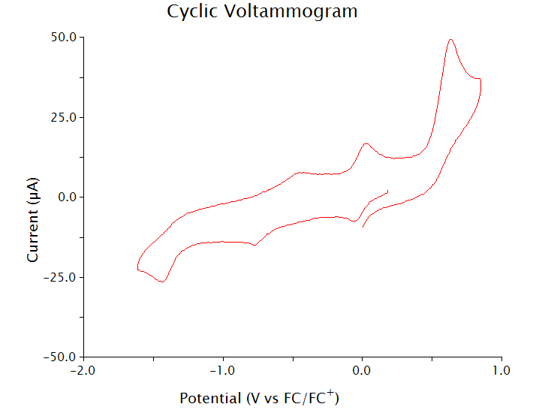

Figure 3.Cyclic Voltammetry of the complex

As shown in Figure 3, three oxidative and three reductive waves appeared. The three oxidative waves at 0,63V,0,029V and at -0,44V can be explained as the protonation of the three nitrogen in the ligands of the complex occurs. And the irreversible reductive waves at -0,053V,0,78V and at -1,45V occurs under the deprotonation of the three nitrogen in the ligands of the complex.[13]
2.2.3 Photocatalytic Water Reduction to Molecular Hydrogen
For the photocatalytic reaction a total of 30ml sample solution was prepared, containing 10⁻⁵ M complex as a catalyst, Fluorescein 1mM as a photosensitizer and TEOA as a sacrificial donor dissolved in H2O:DMF (2:1).The results are shown in Figures 4 and 5.

Figure 4. Light-driven hydrogen production from a system containing 10⁻⁵M complex, fluorescein 1mM,TEOA 0,5M dissolved in DMF:H₂O(1:2)

Figure 5. Light-driven hydrogen production from a system containing 10⁻⁵M complex, fluorescein 1mM,TEOA 0,5M dissolved in DMF:H₂O.(1:2)

The photocatalytic activity of the system is tested and it is long term with a TON_{cat} equals to 445. This activity is among the highest ones observed for Ni(II) compounds acting as reductive catalysts. Thus, this class of compounds is a promising one for low cost, abundant and friendly to environment catalysts for the photoreduction of water.

Acknowledgments
Financial support from Special Research Account of NKUA and the Master of Science Program 'Inorganic Chemistry and its Application to Industry' is gratefully acknowledged.

REFERENCES:
- A. Zarkadoulas, E. Koutsouri, C.A. Mitsopoulou, Coord. Chem. Rev. (2012), 256, 2424-2434.
- Stiefel E.I., Dithiolene Chemistry: Synthesis, Properties and Applications, J. Wiley and Sons,(2004),52.
- R. Humphry-Baker, C. A. Mitsopoulou, D. Katakis and E.Vrachnou, J.Photochem.Photobiol.A:Chem.,(1998), 114, 137-144.
- A. Zarkadoulas, M. J. Field, V. Artero, C. A. Mitsopoulou, ChemCatChem, (2017),9,2308-2317.
- Durgutlu Ahmet Materials & Design 25 (2003),25,19–23.
- Vogel, A.E.:A textbook of Quantitative Inorganic Analysis, Longmans, Green and Co,2nd edition,(1953).
- William T. Eckenhoff and Richard Eisenberg Dalton Trans.(2012),41, 13004-13021
- Athanasios Zarkadoulas, Martin J Field, Constantina Papatriantafyllopoulou, Jennifer Fize, Vincent Artero, Christiana A Mitsopoulou, Inorganic chemistry.(2015),55,432-434.
- Baker-Hawkes, M.-J.; Billig, E.; Gray, H. B. J. Am. Chem. Soc. (1966), 88, 4870-4875.
- Balch, A. L. J. Am. Chem. Soc. (1969), 91, 1948-1953.
- Chen, X. T.; Hu, Y. H.; Wu, D. X.; Weng, L. H.; Kang, B. S. Polyhedron (1991), 10, 2651-2657.
- Balch, A. L.; Holm, R. H. J. Am. Chem. Soc. (1966), 88, 5201-5209.
- Masatoshi Ishida, Soo-Jin Kim, Christian Preihs, Kei Ohkubo, Jong Min Lim, Byung Sun Lee, Jung Su Park, Vincent M. Lynch, Vladimir V. Roznyatovskiy, Tridib Sarma, Pradeepta K. Panda, Chang-Hee Lee Shunichi Fukuzumi, Dongho Kim Jonathan L. Sessler. Nature Chemistry(2013),5,15-20

