SYNTHESIS AND CHARACTERIZATION OF COPPER-BASED PHOTOSENSITIZERS FOR SOLAR ENERGY CONVERSION
Maria Drosouª, George Syrrokostas^{b}, Sofia Stefa^{b}, Spyros N. Yannopoulos^{b}, Christiana A. Mitsopoulouª*
ª Inorganic Chemistry Laboratory, Department of Chemistry, National and Kapodistrian University of Athens, Panepistimiopolis Zografou 15771, Greece
^{b} Institute of Chemical Engineering Sciences, Foundation for Research and Technology Hellas (FORTH/ICE-HT), 26504 Patras, Greece
email: mits1524@gmail.com, cmitsop@chem.uoa.gr
Introduction
World demand for energy is projected to nearly double by 2050 and to triple by the end of the century.¹ Fossil fuels cannot be a long-term solution as they come from a limited stock and their use has resulted in numerous environmental problems.² Solar energy is considered the most promising renewable resource, since the amount of enengy the Sun shines on the Earth every day exceeds by a factor of 10⁴ the present global population consumption. Consequently, covering only around 0.1% of the Earth’s surface by means of energy conversion devices having an efficiency of about 10% would satisfy the present global energy needs.³ Therefore, technologies that collect solar energy and convert it into usable forms of energy, such as electrical energy (photovoltaics) or chemical energy (‘‘solar fuels’’) attract intensive research interest.^{4,5}
The dye sensitized solar cell (DSSC), firstly assembled and demonstrated by O’Regan and Grätzel in 1991,⁶ is a low cost and high efficiency solar energy-to-electricity converter and is based on immobilizing a dye (or sensitizer) on a semiconductor surface.⁷ Upon light absorption, the sensitizer excited-state (S*) promotes electron injection into the conduction band (CB) of the semiconductor.⁸ To regenerate the ground state of the dye, an electron is transferred from the electrolyte, which comprises a redox couple, to the dye. The electrical circuit is completed by reduction of the electrolyte at a platinized counter-electrode.⁹ Immobilization of the dye to a semiconductor is usually achieved by addition of an ‘anchoring group’, i.e. a chemical substituent able to adsorb the dye molecule onto the surface of the metal oxide and creates an interfacial path by which electrons can be transferred from the dye to the semiconductor.¹⁰
In conventional Grätzel n-type DSSCs, the sensitizers are ruthenium(II) complexes.¹¹ The high cost and low abundance of ruthenium, however, inhibit applications of ruthenium dye-based DSSCs on a large scale. Complexes of copper(I) are considered to be viable, low-cost, earth abundant alternative photosensitizers in solar energy conversion technologies.^{12,13} Here, we report the synthesis and characterization of a homoleptic [(Cu(NN-(SO₃Na)₂)₂]⁺ and an heteroleptic [(Cu(PP)(NN-(SO₃Na)₂)]⁺ photosensitizer bearing sulfonate anchor groups and their adsorption in the surface of titania.
Experimental Part
Syntheses. [Cu(bathocuproinedisulfonic acid disodium salt)₂](BF₄) (1). [Cu(MeCN)₄]BF₄ and BCDS 2.0 equivalents were stirred in dried and thoroughly degassed dimethylformamide at room temperature for 24 h under an Ar atmosphere. The solvent was then removed under reduced pressure and the resulting dark red solid was washed with acetonitrile.
[Cu(bathocuproinedisulfonic acid disodium salt)(1,2 Bis(diphenylphosphino)ethane)] (BF₄) (2). [Cu(MeCN)₄]BF₄, dppe and 1.0 equivalent of BCDS were stirred in dried and thoroughly degassed dimethylformamide at room temperature for 24 under an Ar atmosphere at room temperature. The solvent was then removed under reduced pressure and the deep red resulting solid was washed with water and acetonitrile.
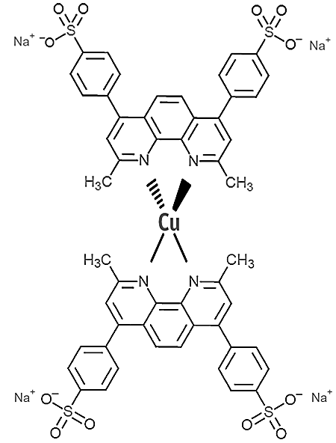 | 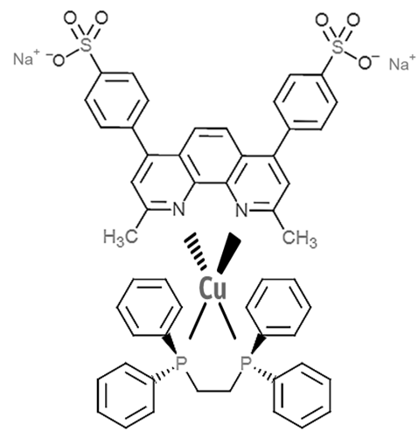
[Cu(BCDS)₂]⁺  (1) | [Cu(BCDS)(dppe)]⁺  (2)
Figure 1. Structures of complexes 1 and 2
Results and Discussion
Photophysical Properties
The absorption spectrum of complexes 1 and 2 are presented in Fig. 2 and 3 respectively. The intense absorption feature around 290 nm is assigned to the π−π* transitions of the phenanthroline ligand. The metal-to-ligand charge transfer (MLCT) absorption dominates the visible region of the spectrum, with a maximum of 481 nm for 1 and 415 nm for 2.
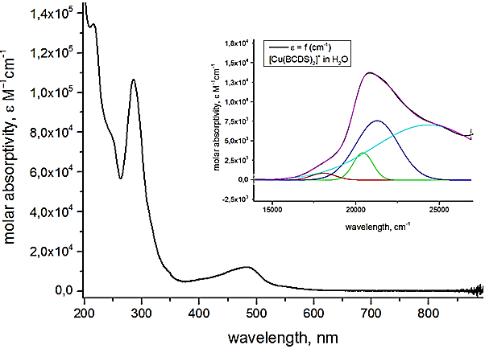
Figure 2. Absorption spectrum of [Cu(BCDS)₂](BF₄) in H₂O solution
The shape of the MLCT absorption band is a good indicator of the ground state geometry of copper(I) bis-phenanthroline complexes.¹⁴ This transition corresponds to the promotion of an electron from a 3d copper orbital to a low lying π* orbital on the phenanthroline ligand. As seen in Fig. 3, this band is an envelope of four distinct MLCT transitions of distinct relative probability. Band I at 553 nm with oscillator strength f=0.0052 can be assigned to a S₀→S₁ transition. This transition propability can function as a measure of the degree of flattening of the copper complex. For a D_{2d} (pseudo-tetrahedral) complex, this excitation has a transition dipole of nearly zero and hence very little oscillator strength, but the oscillator strength increases as the coordination symmetry changes from D_{2d} to D₂ (flattened tetrahedral). Band II consists of two distinct peaks at 490 nm with f=0.020 and at 470 nm f=0.10 and corresponds to a S₀→S₂ transition. This peak separation is attributed to vibronic effects of the C-N bond. Band III at 410 nm is attributed to vibronic effects and is significantly hidden by ligand peaks.
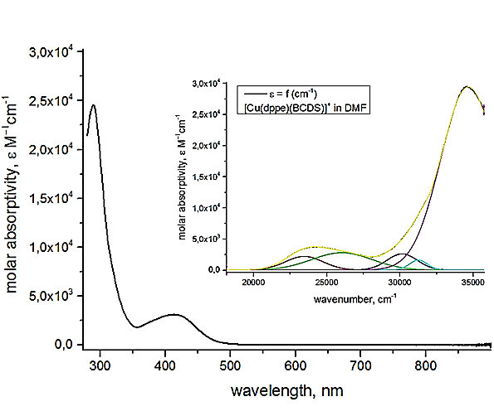
Figure 3. Absorption spectrum of [Cu(BCDS)(dppe)](BF₄) in DMF solution
The MLCT band of complex 2 consists of two peaks at 426 nm with oscillator strength f=0.033 and 384 nm with f=0.065. The absorption transitions of copper(I) diphosphine-diimine complexes are best described in terms of multiconfigurations, using linear combinations of occupied and virtual orbitals.¹⁵
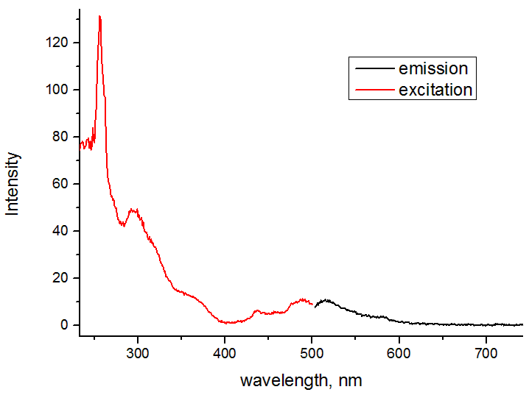
Figure 4. Excitation spectra (red) and emission spectra (black) of complex 1 in DMF solution at room temperature
Complex 1 shows very weak emission in solution at room temperature. Although, it is evidenced that polar solvents usually quench copper (I) complexes by exciplex formation, 1 and 2 are not soluble in any non coordinating solvent. Complex 2 does not show detectable phosphorescence at room temperature in organic solvents, either in the presence of oxygen or in degassed solutions. In a dilute solution, the flexible P(CH₂)₂P chains undergo dynamic intramolecular vibrations, which non-radiatively annihilates the excited state and renders the complex non-luminescent.
Electrochemistry
The electrochemical properties of complexes 1 and 2 were assessed in dry dimethylformamide. Redox potentials of the ground and excited states are gathered in Table 1.
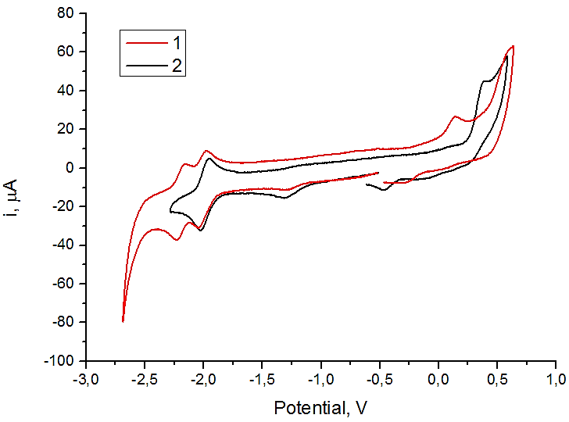
Figure 5. Cyclic voltammetry curves of complexes 1 and 2 in DMF solution, measured using a standard three-electrode arrangement with a glassy carbon working electrode, a platinum wire counter electrode, and an Ag/AgNO₃ reference electrode.

Table 1. Photo- and electrochemical data of PSs in DMF. Potentials are given versus Fc/Fc⁺.
Complex | λ_{abs} (nm) | ε  (M⁻¹ cm⁻¹) | λ_{em} (nm) | E_{ox} (V) | E_{red} (V) | E_{ox}* (V) | E_{red}* (V)
1 | 481 | 12000 | 515 | 0.14 | -2.01 | -2.32 | 0.45
2 | 415 | 4500 | 595 | 0.41 | -1.96 | -2.05 | 0.50
*Minimal excited state potentials were estimated as E_{ox/red} * = E_{ox/red} ± E_{00,min} (E_{00,min} is the emission energy at the intersection of the absorption and emission spectra)
An aspect that has great influence on the performance of a DSSC is the position of molecular orbitals with their energy levels. Figure 6 shows the HOMO and LUMO energy levels for the analyzed complexes and they are compared to the benchmark N719 Ru(II) dye. It is possible to view that the LUMO energy level is above the TiO₂ conduction band and HOMO level is located below the redox of the electrolyte for all complexes.
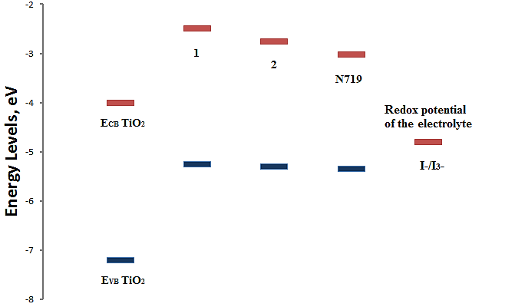
Figure 6. Molecular orbitals energy levels diagram

DSSC Performances
The photovoltaic performance of the complex 1 DSSC are given in Table 2 in comparison to the N719 dye.
Table 2. Photovoltaic data extracted from J vs. applied V measurements under simulated solar light
Complex | V_{oc} (V) | I_{sc}  (mA) | FF | η% | Pmax (mW)
1 | 0,487 | 0,167 | 0,587 | 0,15 | 0,0478
N719 | 0,739 | 6,18 | 0,582 | 7,22 | 2,6577

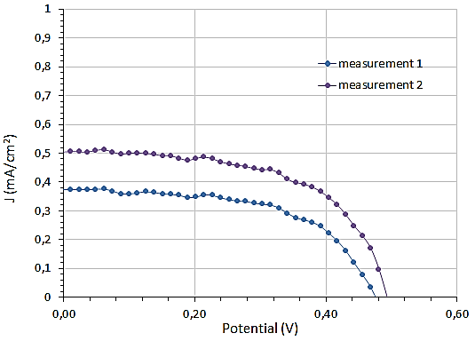
Figure 8. J vs. V curves for compex 1
In conclusion, we have presented the synthesis of a homoleptic [Cu(NN)₂]⁺ (1) and a heteroleptic [Cu(NN)(PP)]⁺ (2) copper complex containing sulfonate linkers as anchor groups. Subsequently, these substances were immobilized on TiO₂ semiconductor in order to achieve light-triggered electron injection from the copper sensitizer into the conduction band of TiO₂. The results of the DSSC performances reinforce the belief that Cu(I)-based complexes with iterative chemical optimization would be competent to provide promising sensitizers for next-generation DSSCs.
Acknowledgments
Financial support from Special Research Account of NKUA and the Master of Science Program 'Inorganic Chemistry and its Application to Industry' is gratefully acknowledged.
References
- Leitner, W., Quadrelli, E. A., & Schlögl, R., Green Chem., 2017, 19(10), 2307-2308.
- Gray, H. B., Nature chemistry, 2009, 1(1), 7-7.
- Grätzel, M., Inorganic chemistry, 2005, 44(20), 6841-6851.
- Tee, S. Y., Win, K. Y., Teo, W. S., Koh, L. D., Liu, S., Teng, C. P., & Han, M. Y., Advanced Science, 2017.
- Gong, J., Sumathy, K., Qiao, Q., & Zhou, Z., Renewable and Sustainable Energy Reviews, 2017, 68, 234-246.
- B. C. O’Regan and M. Grätzel, Nature, 1991, 353, 737–740
- Bella, F., Gerbaldi, C., Barolo, C., Grätzel, M., Chem. Soc. Rev., 2015, 44(11), 3431-3473.
- Watson, D. F., Meyer, G. J., Annu. Rev. Phys. Chem., 2005, 56, 119–156.
- Anderson, A. Y., Barnes, R. F., Durrant, J. R., O ’regan, B. C., J. Phys. Chem. C 2011, 115, 2439–2447.
- Zhang, L., Cole, J. M., ACS applied materials & interfaces, 2015, 7(6), 3427-3455.
- Nazeeruddin, M. K., De Angelis, F., Fantacci, S., Selloni, A., Viscardi, G., Liska, P., Ito, S., Takeru, B., Grätzel, M., 2005, J. Am. Chem. Soc., 127(48), 16835-16847.
- Lazorski, M. S., Castellano, F. N., Polyhedron, 2014, 82, 57-70.
- Housecroft, C. E., Constable, E. C., Chem. Soc. Rev., 2015, 44(23), 8386-8398.
- Sandroni, M., Pellegrin, Y., Odobel, F., C. R. Chimie, 2016, 19(1), 79-93.
- Yang, L., Feng, J. K., Ren, A. M., Zhang, M., Ma, Y. G., Liu, X. D., Eur. J. Inorg. Chem., 2005, 2005(10), 1867-1879.

